**QUIZ • 20 MIN**

**Neural Network Basics**

,

**People are making progress**

**4115** learners have recently completed this assignment

**Submit your assignment**

**DUE**Jan 13, 2:59 AM EST

Start

**Receive grade**

**TO PASS**80% or higher

**Grade**

—

Neural Network Basics

Graded Quiz • 20 min

**Due** Jan 13, 2:59 AM EST

**Neural Network Basics**

**TOTAL POINTS 10**

**1.Question 1**

**What does a neuron compute?**



A neuron computes a linear function (z = Wx + b) followed by an activation function



A neuron computes a function g that scales the input x linearly (Wx + b)



A neuron computes an activation function followed by a linear function (z = Wx + b)



A neuron computes the mean of all features before applying the output to an activation function

1 point

**2.Question 2**

**Which of these is the "Logistic Loss"?**



L(*i*)(*y*^(*i*),*y*(*i*))=−(*y*(*i*)log(*y*^(*i*))+(1−*y*(*i*))log(1−*y*^(*i*)))



L(*i*)(*y*^(*i*),*y*(*i*))=∣*y*(*i*)−*y*^(*i*)∣2



L(*i*)(*y*^(*i*),*y*(*i*))=*max*(0,*y*(*i*)−*y*^(*i*))



L(*i*)(*y*^(*i*),*y*(*i*))=∣*y*(*i*)−*y*^(*i*)∣

1 point

**3.Question 3**

**Suppose img is a (32,32,3) array, representing a 32x32 image with 3 color channels red, green and blue. How do you reshape this into a column vector?**



x = img.reshape((32*32*3,1))



x = img.reshape((32*32,3))



x = img.reshape((1,32*32,*3))



x = img.reshape((3,32*32))

1 point

**4.Question 4**

**Consider the two following random arrays "a" and "b":**



**1**

**2**

**3**

**a = np.random.randn(2, 3) # a.shape = (2, 3)**

**b = np.random.randn(2, 1) # b.shape = (2, 1)**

**c = a + b**

**What will be the shape of "c"?**



The computation cannot happen because the sizes don't match. It's going to be "Error"!



c.shape = (2, 3)



c.shape = (3, 2)



c.shape = (2, 1)

1 point

**5.Question 5**

**Consider the two following random arrays "a" and "b":**



**1**

**2**

**3**

**a = np.random.randn(4, 3) # a.shape = (4, 3)**

**b = np.random.randn(3, 2) # b.shape = (3, 2)**

**c = a*b**

**What will be the shape of "c"?**



The computation cannot happen because the sizes don't match. It's going to be "Error"!



c.shape = (4,2)



c.shape = (3, 3)



c.shape = (4, 3)

1 point

**6.Question 6**

**Suppose you have n_x*nx*​ input features per example. Recall that X = [x^{(1)} x^{(2)} ... x^{(m)}]*X*=[*x*(1)*x*(2)...*x*(*m*)]. What is the dimension of X?**



(1,m)(1,*m*)



(n_x, m)(*nx*​,*m*)



(m,1)(*m*,1)



(m,n_x)(*m*,*nx*​)

1 point

**7.Question 7**

**Recall that "np.dot(a,b)" performs a matrix multiplication on a and b, whereas "a*b" performs an element-wise multiplication.**

**Consider the two following random arrays "a" and "b":**



**1**

**2**

**3**

**a = np.random.randn(12288, 150) # a.shape = (12288, 150)**

**b = np.random.randn(150, 45) # b.shape = (150, 45)**

**c = np.dot(a,b)**

**What is the shape of c?**



c.shape = (150,150)



c.shape = (12288, 45)



c.shape = (12288, 150)



The computation cannot happen because the sizes don't match. It's going to be "Error"!

1 point

**8.Question 8**

**Consider the following code snippet:**



**1**

**2**

**3**

**4**

**5**

**6**

**# a.shape = (3,4)**

**# b.shape = (4,1)**

**for i in range(3):**

**for j in range(4):**

**c[i][j] = a[i][j] + b[j]**

**How do you vectorize this?**



c = a + b.T



c = a.T + b



c = a.T + b.T



c = a + b

1 point

**9.Question 9**

**Consider the following code:**



**1**

**2**

**3**

**a = np.random.randn(3, 3)**

**b = np.random.randn(3, 1)**

**c = a*b**

**What will be c? (If you’re not sure, feel free to run this in python to find out).**



This will invoke broadcasting, so b is copied three times to become (3,3), and *∗ is an element-wise product so c.shape will be (3, 3)



This will invoke broadcasting, so b is copied three times to become (3, 3), and *∗ invokes a matrix multiplication operation of two 3x3 matrices so c.shape will be (3, 3)



This will multiply a 3x3 matrix a with a 3x1 vector, thus resulting in a 3x1 vector. That is, c.shape = (3,1).



It will lead to an error since you cannot use “*” to operate on these two matrices. You need to instead use np.dot(a,b)

1 point

**10.Question 10**

**Consider the following computation graph.**

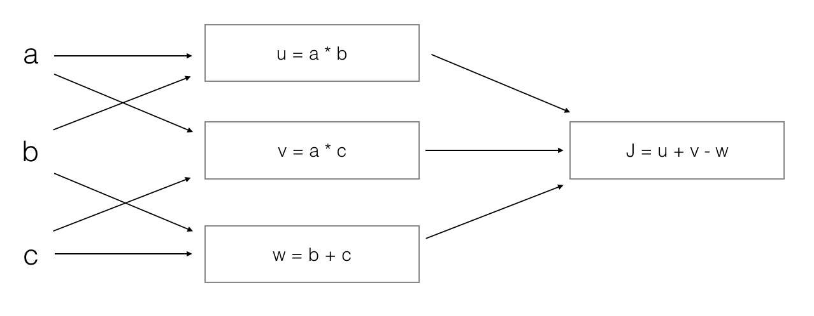

**What is the output J?**



J = (c - 1)*(b + a)



J = (a - 1) * (b + c)



J = a*b + b*c + a*c



J = (b - 1) * (c + a)

1 point



I, **Weifeng Yan**, understand that submitting work that isn’t my own may result in permanent failure of this course or deactivation of my Coursera account. Learn more about Coursera’s Honor Code